**Lab 11**

**Speech and Image Processing**

Group assignment up to 3 students per group.

**Question** 10 marks

**Linear transformations like translation, rotation, scaling etc. can be applied on images by multiplying the image pixels by a 3x3 matrix**

For translation of a pixel (x,y) by distance dx,dy pixels. Origin is the top left corner of the image.

New coordinates are obtained by multiplying input coordinate vector with transformation matrix

|x’| | 1 0 dx | |x|

|y’| = | 0 1 dy | |y|

| 1| | 0 0 1 | |1|

For rotation by angle θ

|x’| | cosθ -sinθ 0 | |x|

|y’| = | sinθ cosθ 0 | |y|

| 1| | 0 0 1 | |1|

For scaling of image by Sx, Sy

|x’| | Sx 0 0 | |x|

|y’| = | 0 Sy 0 | |y|

| 1| | 0 0 1 | |1|

**Write a MATLAB/Octave *.m file script that calculates a transformed image B, given a transformation matrix and an input image A**

# Start of MATLAB/Octave code below

A=imread('cars.jpg');

A=double(A)/255;

# transformation matrix is T

theta=0.5

T=[cos(theta) -sin(theta) 0; sin(theta) cos(theta) 0; 0 0 1]

figure;

imshow(A,[]);

[...rest of the code to calculate the transformed image B...]

Hint: In this problem, given the (x’,y’) coordinates in the “transformed” image, we need to calculate the “original” coordinates (x,y)

For calculating the colour values at non-integer pixel coordinates, use round() function

**Deliverables:**

MATLAB/Octave code file ***transform1.m***

Original image e.g. ***cars.jpg***. The image should be different for each group.

Translated image ***translated.jpg*** by some offset dx,dy pixels

Rotated image ***rotated.jpg*** by some angle theta

Scaled image ***scaled.jpg*** by some factors Sx,Sy

**Example**

Input image cars.jpg

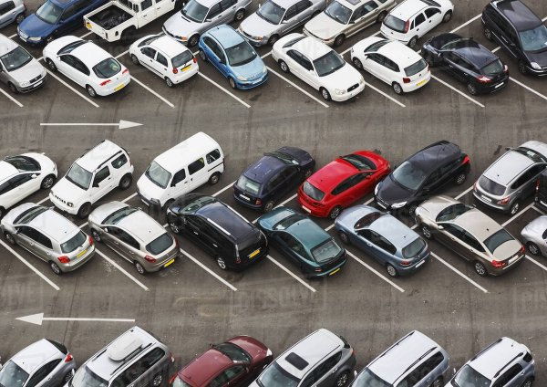

Rotated image rotated.jpg by angle 0.5 radians

